This document describes how to get a Medicare Part D quote from www.Medicare.gov, which has a new look and feel. The following screen shots illustrate the new process for navigating the updated Medicare website.

The first step to produce a Part D quote for either a PDP or an MAPD plan is to click on “Health and Drug Plans” located in the left side.
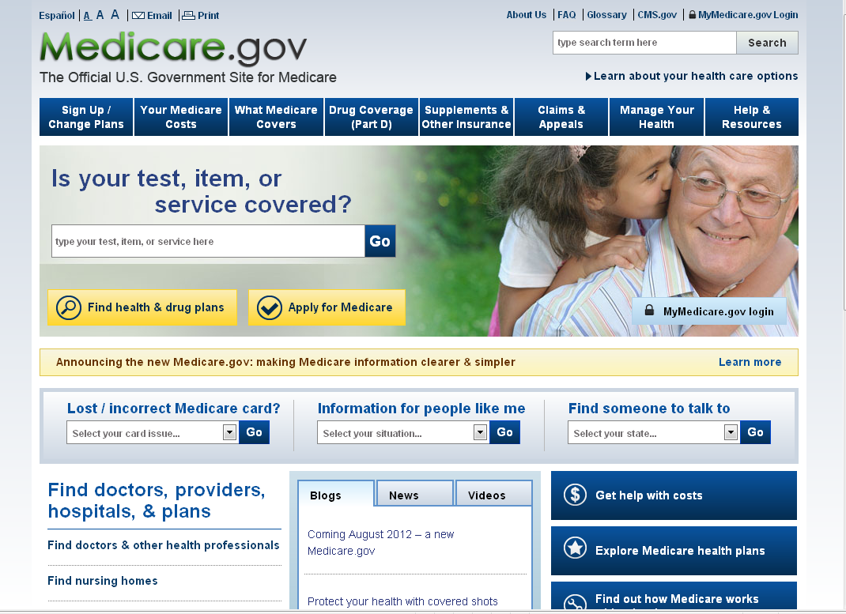

You can do a general search by just entering zip code. This zip code will be used to locate pharmacies in the zip code entered.
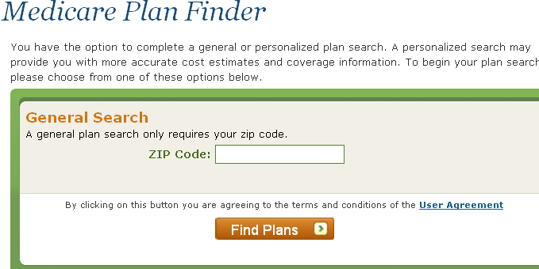
If you have the Medicare claim number and other identifying information and want to do a more personalized search, enter that in the next field. If you do not have a claim number, simply add any numbers you want followed by the letter “A”. Example – 123456789A.
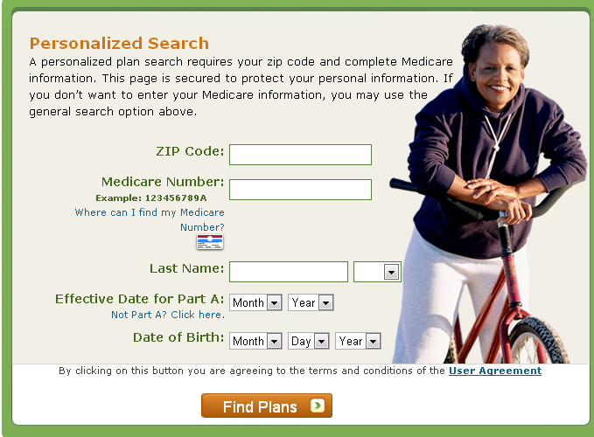

Generally, a search using just the zip code should work just fine.
It will then ask how you currently get Medicare coverage. The answers here are not real important, unless you know you receive extra help and you want to make sure the plans are LIS or Medicaid appropriate.
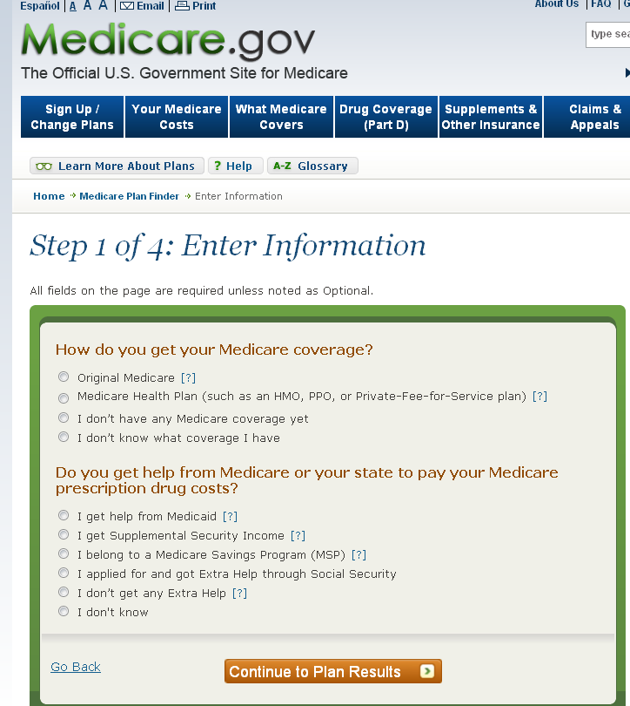

Step 2 of 4 – “Enter Your Drugs”
For this example, Lipitor was chosen. Notice the drop down box that appears as you enter the name of the drug. This change was made to make it easier to enter the correct spelling of the drug, a common problem in the prior version.

Also, if you are revising a prior quote, this is the screen where you would enter the person’s “Drug List ID” and “Password Date”. This is the same procedure as the previous version required.

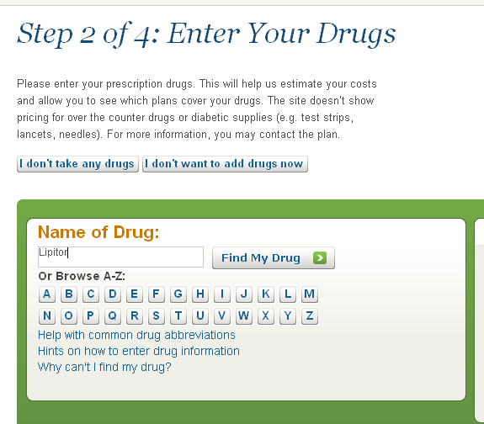
If a lower cost generic is available, you will be prompted to choose that if desired.
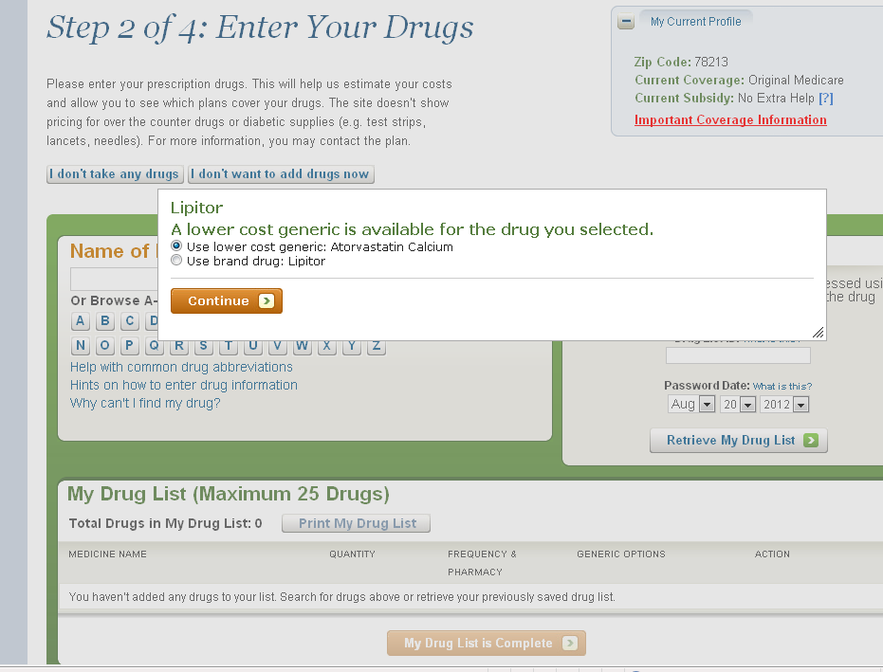
The next box shown will show the various “Dosages” available, the “Quantity”, and finally and “Frequency”. This should aide in identifying the proper drug prescribed, leading to a more precise quote. When you have confirmed the data, click “Add Drug and Dosages”.
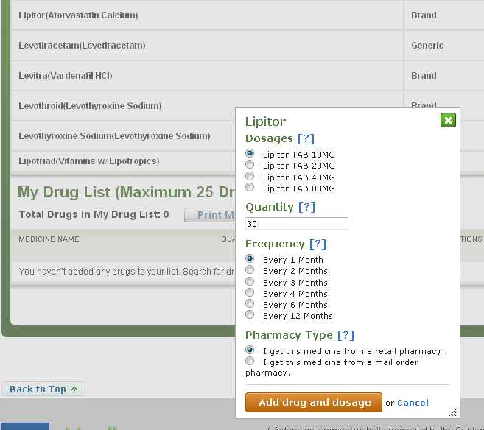

Step 2 of 4 continued. As you will see, the drug “Lipitor” now appears in “My Drug List”. Either add more drugs, or if you have finished, click “My Drug List is Complete”.
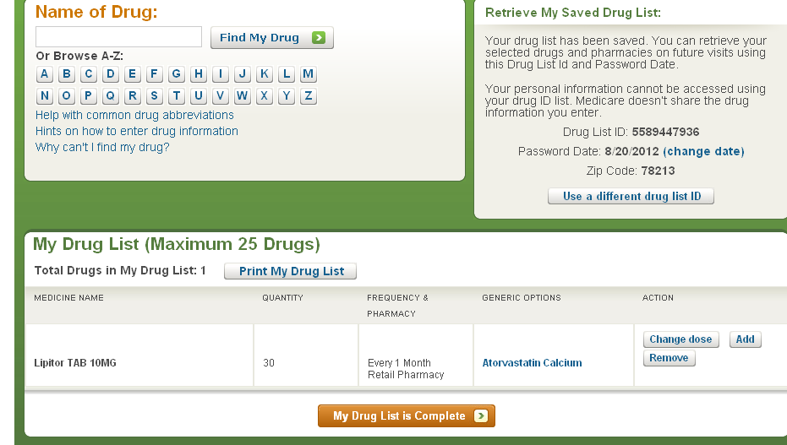

Step 3 of 4: Select Your Pharmacies
New to this function is an online map that will aide in the proper location of the person’s favorite pharmacy. Keep in mind that the relationship between a Medicare Beneficiary’s Pharmacist is just as important as their relationship with their primary care physician. Many times they are on a first name basis with the Pharmacist.

Selecting a preferred pharmacy
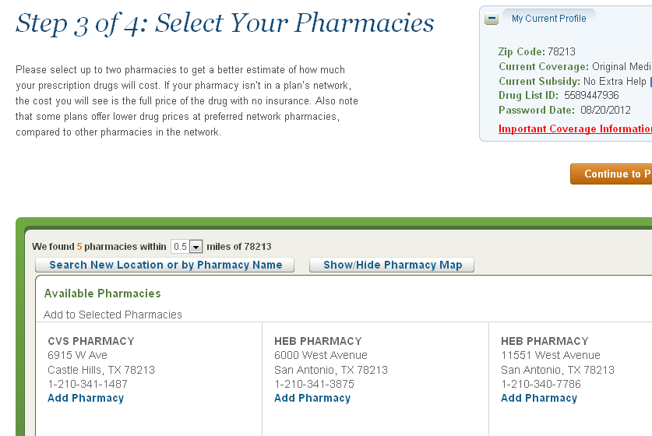
There is a Pharmacy Map option that will show you a map of the closest pharmacies.
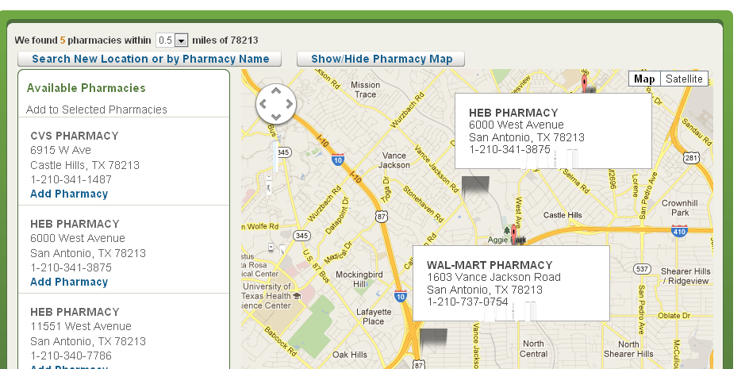

Click “Add Pharmacy” to select a pharmacy in the area of the zip code you entered. Then, click “Continue to Plan Results”.

At this point, you have additional ways to “Refine Your Plan Results”. You may choose to view all plans, or you may view specific plans, like Prescription Drug Plans only.
As you will see, there is a feature to limit your choices by sliding the cursor up or down the premium scale of $0-$104.
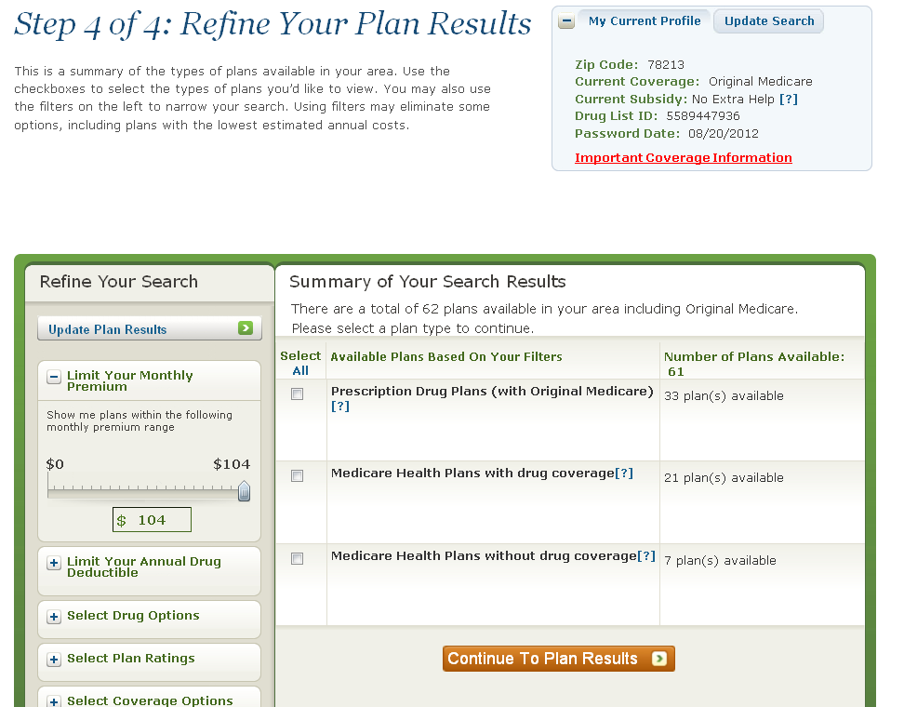
You can refine the deductibles, and other options as well.

Once you have refined your plan selection, you are ready to view your results. You may view all quotes, or just certain styles, like MAPD only, for example.
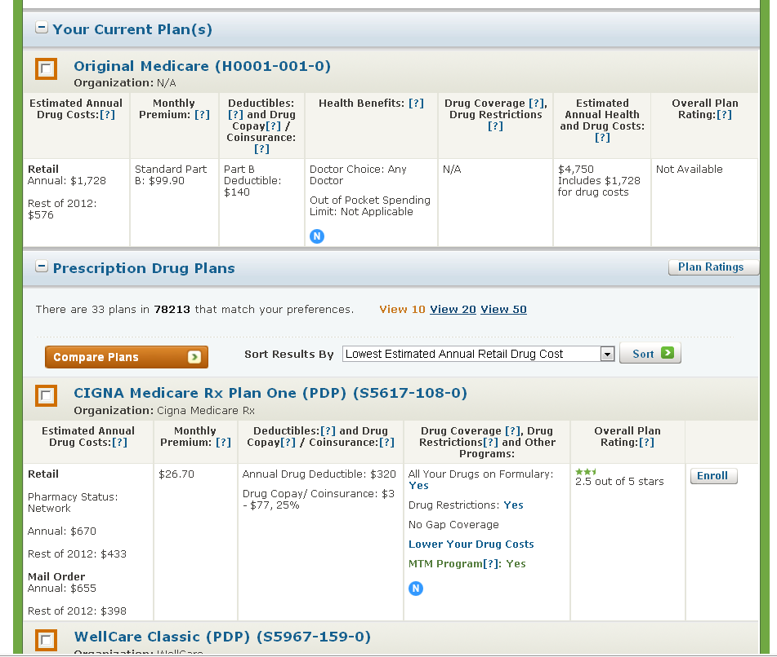

Like the previous web version, you will select the plans you would like to compare.

Once you reach this point, you will notice there are new “tabs” to choose from, giving you and your customers more detailed information regarding your selected plans.
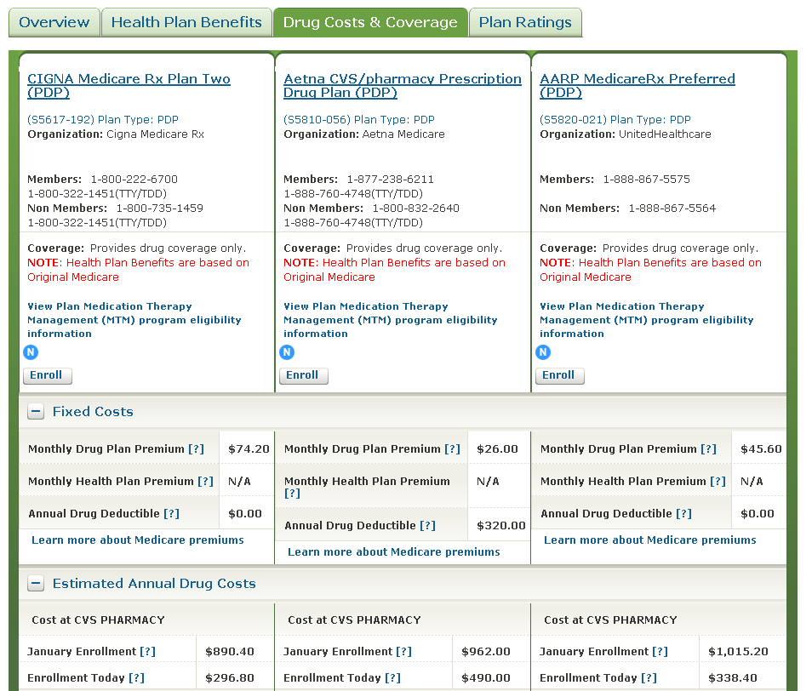

Keep in mind, Health Care Reform placed more emphasis on “Plan Ratings”. In the coming years, both providers and plans will be graded on a five star rating system, which will define the modest bonuses in which the participating plans and providers may qualify based upon several measuring factors.
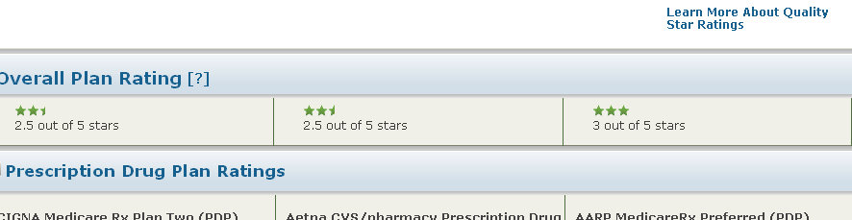

In addition to PDP quotes, you may request MAPD quotes. Click on which plans you would like to compare.
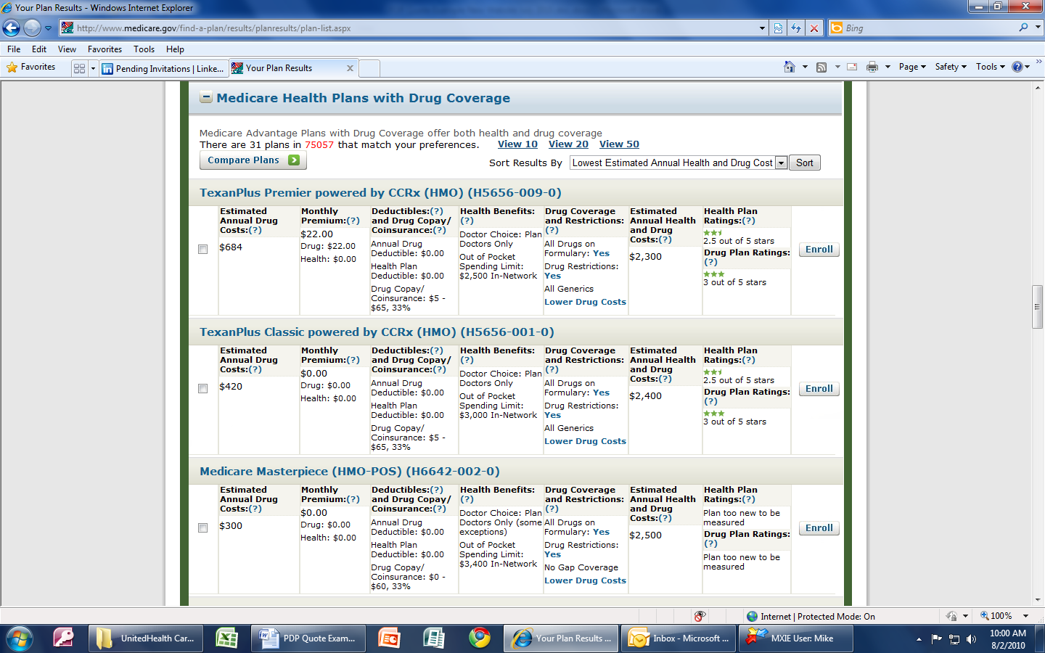

MAPD quotes have the exact look and feel of the PDP quotes.
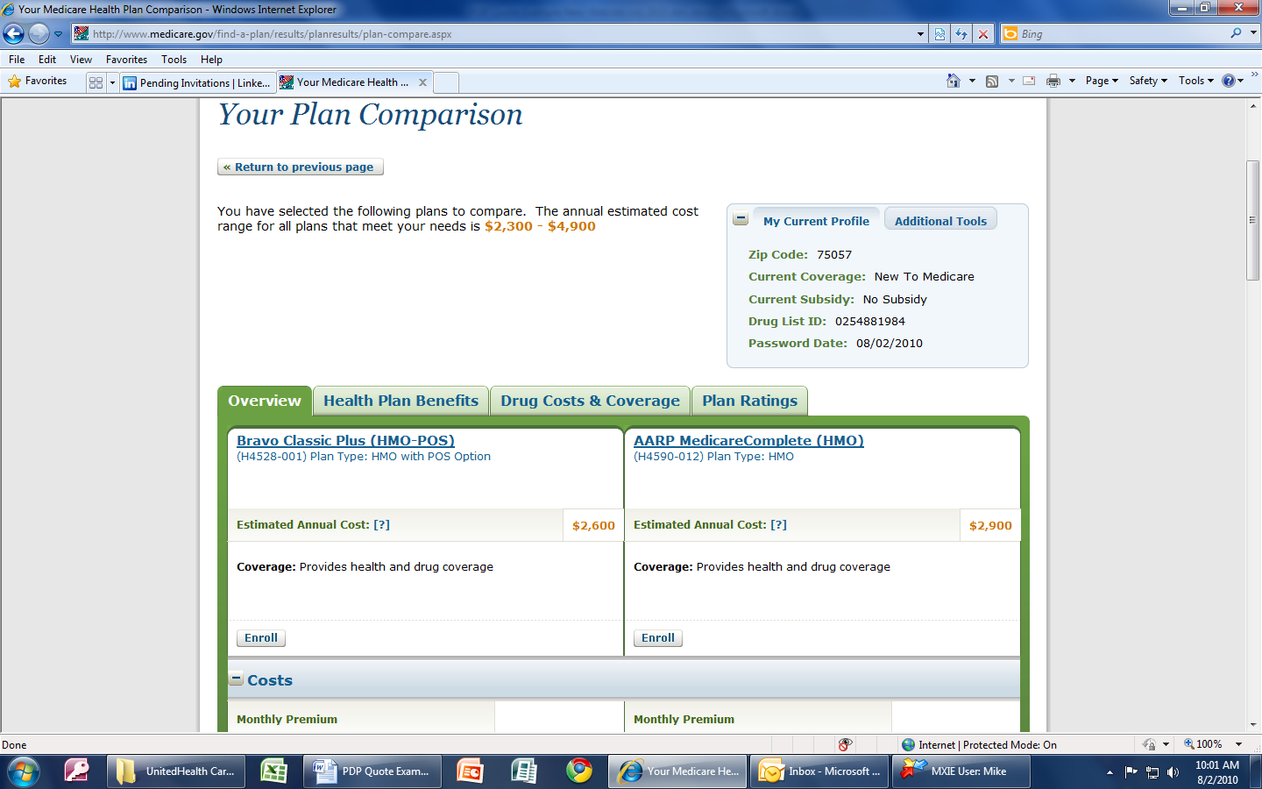

You can view plan details as well:
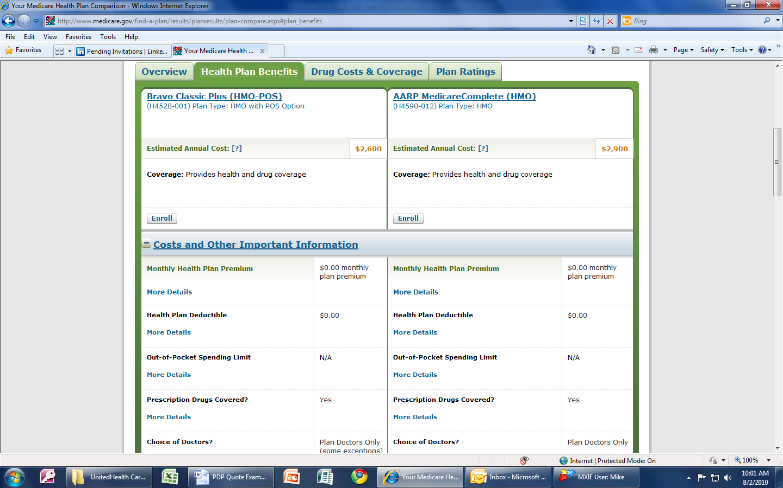

If you click “Additional Tools” this box will pop up – “Learn More About Plans”.


